**GrainPalette: A Deep Learning Odyssey in Rice Type Classification Through Transfer Learning**

**1. INTRODUCTION**

**1.1 Project Overview**

GrainPalette is a Rice Type Classification Web Application developed using Flask and deep learning. It helps users identify different rice grain types using an AI model trained with MobileNetV4 and transfer learning.

**1.2 Purpose**

To offer a fast and accurate web-based rice type identification system, aiding farmers, researchers, and gardeners in crop planning, agricultural research, and educational activities.

**2. IDEATION PHASE**

**2.1 Problem Statement**

Identifying rice types by visual inspection can be time-consuming and error-prone, especially for non-experts. A deep learning-based tool can assist users in determining rice varieties from images with high accuracy.

**2.2 Empathy Map Canvas**

* **Users:** Farmers, agricultural scientists, home growers
* **Needs:** Quick and reliable rice grain classification
* **Pain Points:** Manual identification errors, lack of instant support
* **Gains:** Instant and accurate rice type predictions

**2.3 Brainstorming**

Reviewed popular CNN models for image classification. Chose MobileNetV4 for its lightweight design and performance. Designed a user-friendly web interface using Flask, HTML, and CSS.

**3. REQUIREMENT ANALYSIS**

**3.1 Customer Journey Map**

1. User uploads a rice grain image.
2. System classifies it into one of five rice types.
3. User views the prediction and makes cultivation-related decisions.

**3.2 Solution Requirements**

* Deep learning model (MobileNetV4)
* Flask web application
* Image preprocessing tools
* Dataset of labeled rice grain images

**3.3 Data Flow Diagram**

*(Insert DFD here showing User → Flask → Model → Prediction → Result)*

**3.4 Technology Stack**

* **Languages:** Python
* **Frameworks:** Flask, TensorFlow (Keras)
* **Frontend:** HTML, CSS
* **Model:** MobileNetV4

**4. PROJECT DESIGN**

**4.1 Problem Solution Fit**

* The model automates rice variety identification, eliminating human error and enabling data-driven agriculture.

**4.2 Proposed Solution**

* A Flask-based app where users upload an image. The model processes it and returns the predicted rice type along with probabilities.

**4.3 Solution Architecture**

* User → Flask App → MobileNetV4 Model → Prediction → Result

**5. PROJECT PLANNING & SCHEDULING**

**5.1 Project Timeline**

* **Week 1:** Dataset collection, cleaning, and augmentation
* **Week 2:** Model training and evaluation using MobileNetV4
* **Week 3:** Flask web app and UI integration
* **Week 4:** Testing, deployment, and documentation

**6. FUNCTIONAL AND PERFORMANCE TESTING**

**6.1 Performance Testing**

* Evaluated prediction speed, model accuracy, and responsiveness of the app. The model showed consistent results for varied image inputs with low latency on local machines.

**7. RESULTS**

**7.1 Output Screenshots**

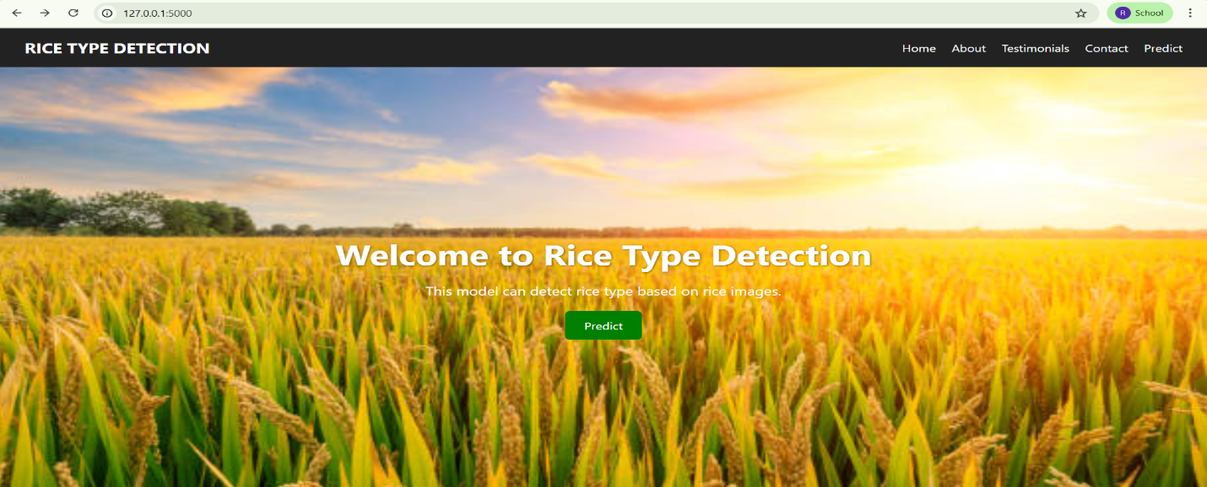

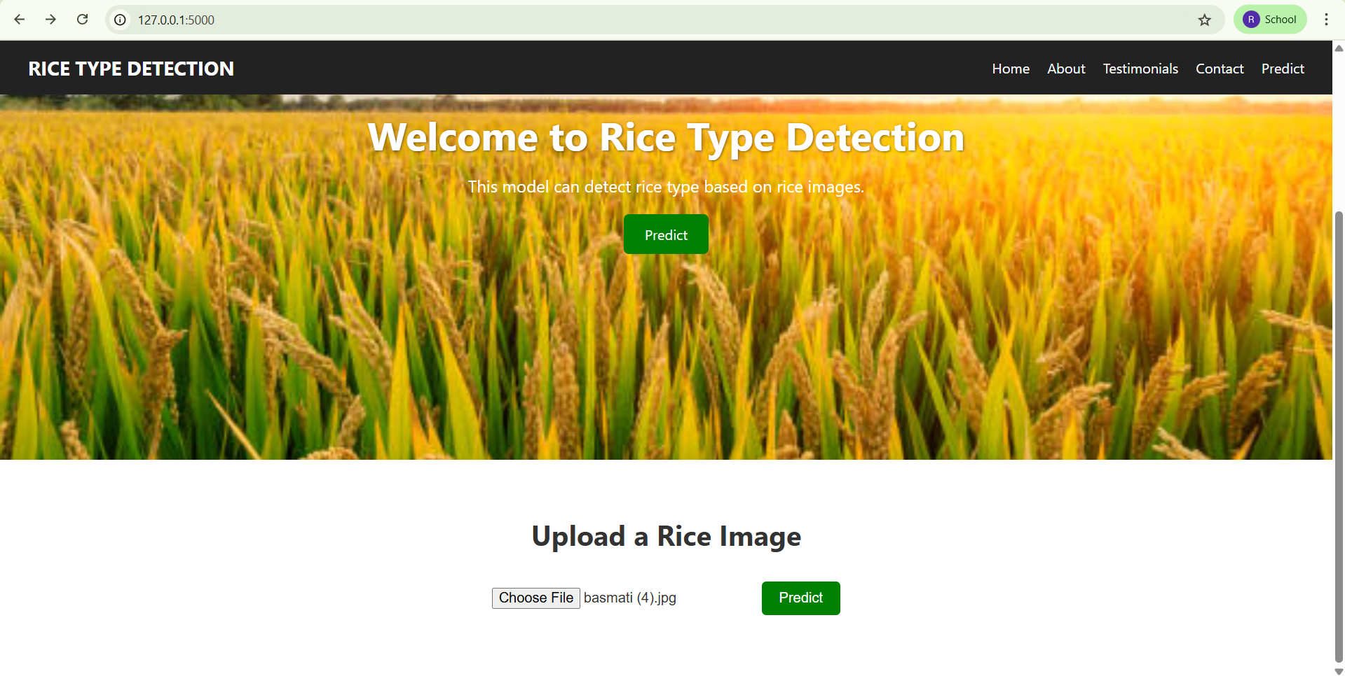

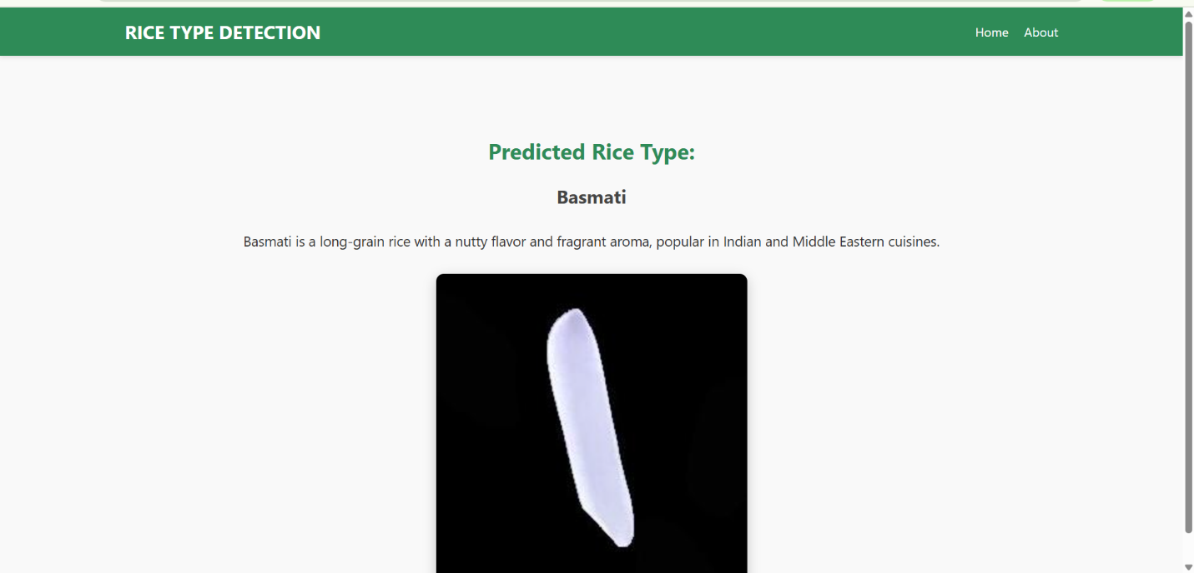

**8. ADVANTAGES & DISADVANTAGES**

**Advantages:**

* Accurate and real-time predictions
* Supports agricultural planning and research
* Simple and intuitive web interface

**Disadvantages:**

* Performance depends on dataset quality
* High GPU requirement for training
* Web interface currently only in English

**9. CONCLUSION**

GrainPalette successfully uses AI and transfer learning to simplify and automate the task of identifying rice varieties. It has strong use cases in agriculture, education, and research.

**10. FUTURE SCOPE**

* Cloud deployment for scalability
* Expansion to more rice grain types
* Mobile app version for offline field use
* Multilingual interface support

**11. APPENDIX**

* **Source Code:** app.py, model.py, HTML templates
* **GitHub Repository:**
* **Model File:** rice.h5